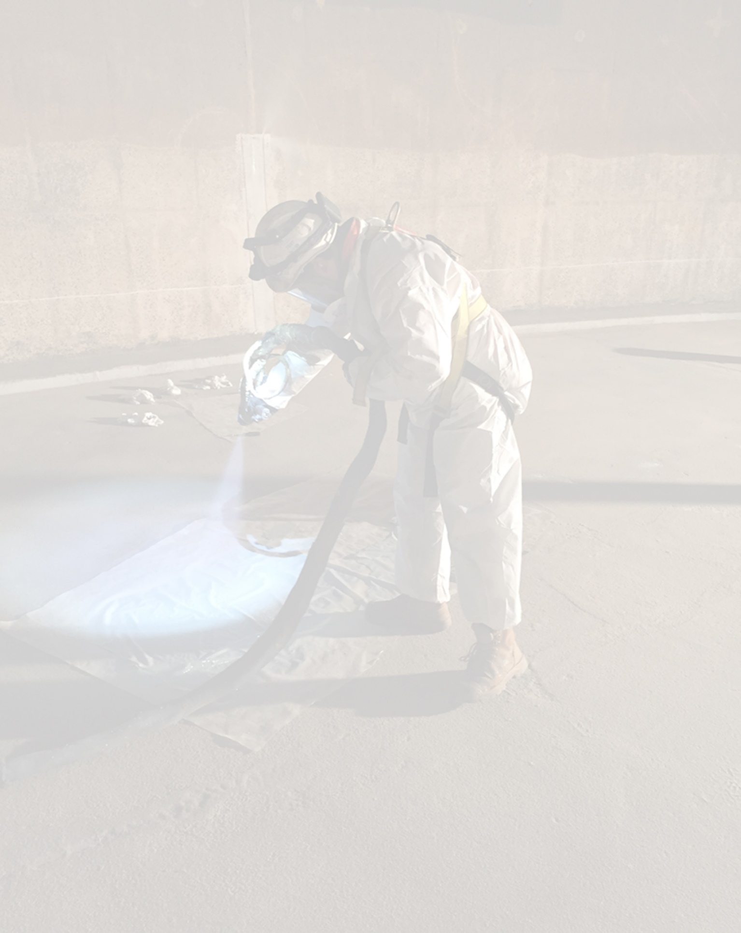The Golden Trowel Award

# **What is the Golden Trowel Award?**

# The Golden Trowel Award was established in 2019 by the ACA’s Applicators Technical Group. The purpose of the award is to honor a concrete remediation and protection contractor for their meritorious and/or innovative performance in the field, or in recognition of significant contribution to their industry. Nominations are particularly encouraged from contractors and applicators either as a Company or individuals within Australasia and New Zealand.

# **What do you receive?**

The Golden Trowel Award recipient is recognized by the industry at the annual ACA Conference Awards night and is included in the prestigious award honor role.

The recipient is given the right to display the award logo on digital and printed media.

# **Who has won the award previously?**

***Honour Role***

Past recipients of the Rust Award are listed below:

**2019 – Jamie Fenton, New South Wales**

# **Get nominated!**

# We often know someone within in our industry who goes about their work making significant contributions in training and mentoring others, using new methods and/or practices in job delivery, innovative application processes, a supervisor, foreman and/or controller on significant projects.

# These persons often go unrecognised outside their own company. However, their contribution paves the way for new entrants to advance our industry. As an industry we need to celebrate these achievements. Nomination forms can be found overleaf and on the ACA website here.

# More information overleaf.

# **Timeline**

Nominations close 30th August each year.

Nominations received after 30th August will be considered for the following year.

|  |  |  |  |  |  |  |  |
| --- | --- | --- | --- | --- | --- | --- | --- |
| Proposer must be an ACA member | | | | | | | |
| ACA Member # | |  | Are you a current ACA member? | | | |  |
| Date: | |  | Proposer name: | |  | | |
| Phone: | |  | Email: | |  | | |
| Job Position: | |  | Company: | |  | | |
| Address: | |  | | | | | |
| Relationship to nominated person: | | | | | | | |
|  | | | | | | | |
| Nominee | | | | | | | |
| Name |  | | | Proposer name: | |  | |
| Phone: |  | | | Email: | |  | |
| Current Job Position: |  | | | Current Company: | |  | |

|  |  |  |  |
| --- | --- | --- | --- |
| Reference 1 for nominee | | | |
| Name |  | Mobile: |  |
| Location: |  | Email: |  |
| Relationship to nominee |  | | |

|  |  |  |  |
| --- | --- | --- | --- |
| Reference 2 for nominee | | | |
| Name |  | Mobile: |  |
| Location: |  | Email: |  |
| Relationship to nominee |  | | |

|  |  |  |  |
| --- | --- | --- | --- |
| Reference 3 for nominee | | | |
| Name |  | Mobile: |  |
| Location: |  | Email: |  |
| Relationship to nominee |  | | |

|  |  |  |  |
| --- | --- | --- | --- |
| Optional – Who can we contact for personal information?  We aim to provide a presentation about the award winner where photos and reference materials can be shown. | | | |
| Name |  | Mobile: |  |
| Location: |  | Email: |  |
| Relationship to nominee |  | | |



|  |
| --- |
| Reason for nomination |
|  |

|  |  |  |  |
| --- | --- | --- | --- |
| I hereby declare the above information is true and correct and nominate the person for the prestigious Golden Trowel Award. | | | |
|  |  |  |
| ______________________  Signed  *(digital signature accepted)* | _______________________________________  **Print Name** | ____________  **Date** |

Upload the completed form to the ACA website. [Golden Trowel Award](https://www.corrosion.com.au/membership/awards/the-golden-trowel-award/https://www.corrosion.com.au/membership/awards/the-golden-trowel-award/)

# **Additional information**

**Nominations should be guided by the following criteria:**

* For outstanding achievement in concrete remediation and protection, demonstrating innovation, durability or utility. The qualities that may represent outstanding achievement in this area include excellence in craftsmanship or execution of work, use of state-of-the-art techniques or products to creatively solve problems or provide long-term service
* For an outstanding industrial or commercial concrete remediation and protection project demonstrating longevity of the original concrete remediation and protection.
* For outstanding achievement demonstrating aesthetic merit in industrial concrete remediation and protection work. The qualities considered for aesthetic merit include finish where the remediation and protection compliment the environment whilst enhancing the structure itself.
* For outstanding achievement in the completion of a difficult or complex industrial concrete remediation and protection project. The qualities that may represent achievement in a difficult or complex structure may include work occurring in harsh or extreme environmental conditions; work completed under strict time constraints; work done with limited access or in high traffic areas; work on a structure with complex structural components; or a project that requires coordination with multiple trades or sub-contractors.

**I propose that the above Concrete Remediation and Protection Contractor be considered for the Rust Award and I accept the conditions of the Award as set out below:**

1. The Judge’s decision is final.
2. The Award is open to all Concrete Remediation and Protection Contractor members of the ACA. The recipient does not necessarily have to be a member of the ACA. The award shall be presented at the ACA Annual Conference.
3. This application must be accompanied by a synopsis of 200-1500 words outlining the reason for nomination.
4. Nominations may be made by any person and should comprise sufficient documentation to enable due consideration of each candidate. This would normally include positions held, experience, commercial and industrial achievements and contributions to developments in protective coatings.
5. The award shall be made annually, and no person may receive the award in consecutive years. In the event of no suitable candidates, the award may not be given.
6. This application maybe lodged with the ACA Chief Executive Officer at any time during the year, but no later than the 15th August to be eligible for consideration in that particular year.