The Rust Award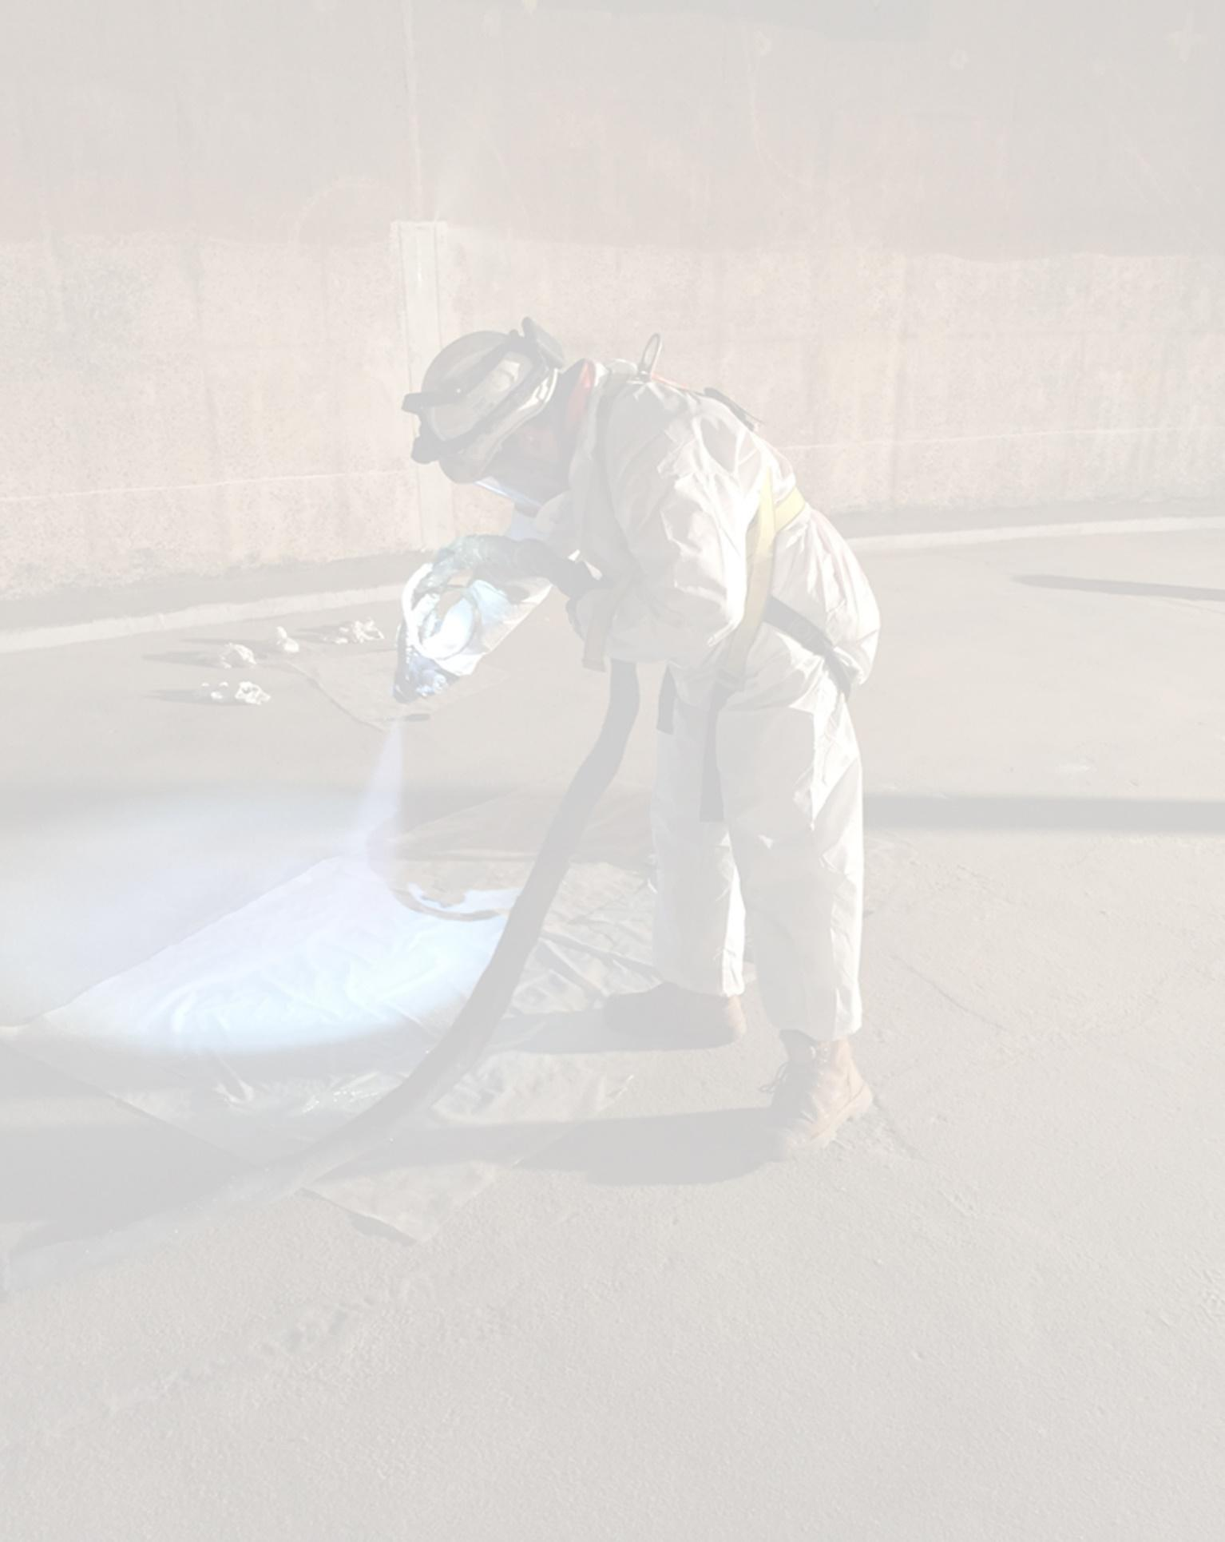

# **What is the Rust Award?**

The Rust Award was established by Blast Cleaning & Coating Association, now a part of the ACA’s Applicators Technical Group. The purpose of the award is to honour a protective coatings contractor for their meritorious and/or innovative performance in the field, or in recognition of significant contribution to their industry. Nominations are particularly encouraged from contractors and applicators either as a Company or individual within Australasia and New Zealand.

# **What do you receive?**

The Rust Award recipient is recognized by the industry at the annual ACA Conference awards night and is included in the prestigious award honor role.

The recipient is given the right to display the award logo on digital and printed media.

# **Who has won the award previously?**

***Honour Role***

Past recipients of the Rust Award are listed below:

**2007 – Terry Iannello, Western Australia 2016 – Craig Ross, New Zealand**

**2008 – Graham Matthews, New Zealand 2018 – Darryl Seacomb, Adelaide**

**2012 – Paul Jeffs & Col Mears, Queensland 2019 – Eddy & Tommy Batur, Victoria**

**2013 – Jeff Greve, Queensland**

# **Get nominated!**

We often know someone in our industry who goes about their work making significant contributions in training and mentoring others, new methods and/or practices in job delivery, innovative application processes, job foreman and/or controller on significant projects.

More information overleaf.

These persons often go unrecognized outside of their own company. However, their contribution lights the way for new entrants to advance our industry. As an industry we need to celebrate these achievements. Nomination forms can be found overleaf and on the ACA website [here.](https://www.corrosion.com.au/membership/awards/the-rust-award/)

# **Timeline**

Nominations close 30th of August each year.

Nominations can be received anytime however any received after 15th of August will be considered for the following year.

|  |  |  |  |  |
| --- | --- | --- | --- | --- |
| Proposer must be an ACA member | | | | |
| ACA Member # |  | Are you a current ACA member? | | Yes / No |
| Date: |  | Proposer name: |  | |
| Phone: |  | Email: |  | |
| Job Position: |  | Company: |  | |
| Address: |  | | | |
| Relationship to nominated person: | | | | |
|  | | | | |

|  |  |  |  |
| --- | --- | --- | --- |
| Nominee | | | |
| Name |  | Proposer name: |  |
| Phone: |  | Email: |  |
| Current Job Position: |  | Current Company: |  |

|  |  |  |  |
| --- | --- | --- | --- |
| Reference 1 for nominee | | | |
| Name |  | Mobile: |  |
| Location: |  | Email: |  |
| Relationship to nominee |  | | |

|  |  |  |  |
| --- | --- | --- | --- |
| Reference 2 for nominee | | | |
| Name |  | Mobile: |  |
| Location: |  | Email: |  |
| Relationship to nominee |  | | |

|  |  |  |  |
| --- | --- | --- | --- |
| Reference 3 for nominee | | | |
| Name |  | Mobile: |  |
| Location: |  | Email: |  |
| Relationship to nominee |  | | |

|  |  |  |  |
| --- | --- | --- | --- |
| Optional – Who can we contact for personal information?  We aim to provide a presentation about the award winner where photos and reference materials can be shown. | | | |
| Name |  | Mobile: |  |
| Location: |  | Email: |  |
| Relationship to nominee |  | | |

|  |
| --- |
| Reason for nomination |
| Information to include work history and areas of significant contribution.  Use separate page for additional information. |

|  |  |  |  |
| --- | --- | --- | --- |
| I hereby declare the above information is true and correct and nominate the person for the prestigious Rust Award. | | | |
|  |  |  |
| ______________________  Signed  *(digital signature accepted)* | _______________________________________  **Print Name** | ____________  **Date** |

Nomination forms must be submitted on [this link.](https://forms.monday.com/forms/6e4b974837ccfe758c7bfd56e2dfa6cb?r=use1)

# **Additional information**

**Nominations should be guided by the following criteria:**

* For outstanding achievement in commercial coatings work, demonstrating innovation, durability or utility. The qualities that may represent outstanding achievement in this area include excellence in craftsmanship or execution of work, use of state of the art techniques or products to creatively solve problems or provide long-term service
* For an outstanding industrial or commercial coatings project demonstrating longevity of the original coating. (The structure may have had spot repairs or over coating with the original coating still intact)
* For outstanding achievement demonstrating aesthetic merit in industrial coatings work. The qualities considered for aesthetic merit includes colour, gloss or texture, or where the coating compliments the environment while enhancing the structure itself. The coating may represent a theme, an object or a specific graphic design
* For outstanding achievement in the completion of a difficult or complex industrial coatings project. The qualities that may represent achievement in a difficult or complex structure may include work occurring in harsh or extreme environmental conditions; work completed under strict time constraints; work done with limited access or in high traffic areas; work on a structure with complex structural components; or a project that requires coordination with multiple trades or sub-contractors.

**I propose that the above Coatings Contractor be considered for the Rust Award and I accept the conditions of the Award as set out below:**

1. The Judge’s decision is final.
2. The Award is open to all Coatings Contractor members of the ACA. The recipient does not necessarily have to be a member of the ACA. Although not mandatory, the recipient would normally be resident in the State or Country in which the Annual Conference is held. The award shall be presented at the ACA Annual Conference
3. This application must be accompanied by a synopsis of 200-1500 words outlining the reason for nomination.
4. Nominations may be made by any person and should comprise sufficient documentation to enable due consideration of each candidate. This would normally include positions held, experience, commercial and industrial achievements and contributions to developments in protective coatings.
5. The award shall be made annually and no person may receive the award in consecutive years. In the event of no suitable candidates, the award may not be given.
6. This application maybe lodged with the ACA Chief Executive Officer at any time during the year, but no later than the 15th of August to be eligible for consideration in that particular year.