Award Nomination Form Victor Nightingall Award

What is the Nightingall Award?
Victor Nightingall (1881-1947) was a leading 20th Century Australian scientist and inventor based in Melbourne. He invented and patented the world’s first inorganic zinc silicate coating and founded the inorganic zinc coating industry in the 1940s .
The Victor Nightingall Award was established in 1998 by the Australasian Corrosion Association (ACA) in honour of Victor Nightingall. The award is given to recognise distinguished achievement in the development, manufacture or application of protective coatings or advancement of the protective coatings industry. Guidelines of this Award are below:
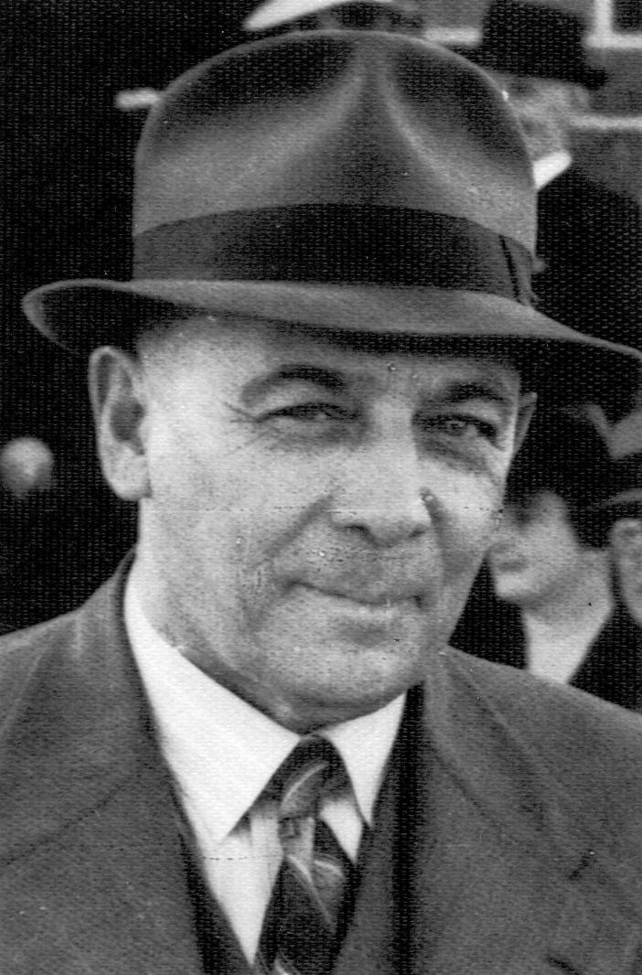  Figure 1 - Victor Nightingall |  | 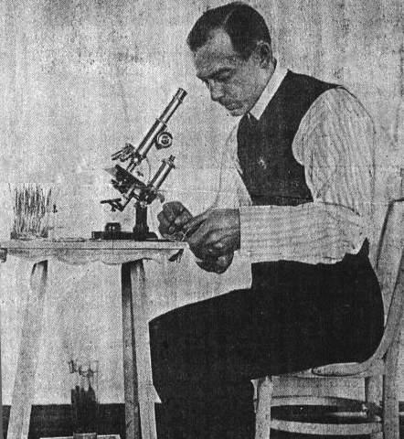  Figure 2 - Victor Nightingall

Figure 3 – Morgan to Whyalla Pipeline famous for its first large scale use of inorganic zinc coating.

Proposer must be an ACA member
ACA Member # |  | Are you a current ACA member? |  | Yes / No
Date: |  | Proposer name:
Phone: |  | Email:
Job Position: |  | Company:
Address:
Relationship to nominated person:

Nominee
Name |  | Proposer name:
Phone: |  | Email:
Current Job Position: |  | Current Company: | Nominee can be retired

Reference 1 for nominee
Name |  | Mobile:
Location: |  | Email:
Relationship to nominee

Reference 2 for nominee
Name |  | Mobile:
Location: |  | Email:
Relationship to nominee

Reference 3 for nominee
Name |  | Mobile:
Location: |  | Email:
Relationship to nominee

Optional – Who can we contact for personal information?
We aim to provide a presentation about the award winner where photos and reference materials can be shown.
Name |  | Mobile:
Location: |  | Email:
Relationship to nominee

Reason for nomination
Information to include work history and areas of significant contribution.
Use separate page for additional information.

I hereby declare the above information is true and correct and nominate the person for the prestigious Victor Nightingall Award.
______________________  Signed  (digital signature accepted) | _______________________________________  Print Name | ____________  Date
Email completed form to Coatings Technical Group Chairperson: justin.rigby@remedyap.com.au or aca@corrosion.com.au

Additional information
Nominations should be guided by the following criteria:
I propose that the above individual be considered for the Victor Nightingall Award and I accept the conditions of the Award as set out below:
- The award, a certificate, will be made annually in recognition of distinguished achievement in the development, manufacture or application of protective coatings or advancement of the protective coatings industry.
- In the event of no suitable candidates, the award will not be given that year.
- Nominations shall be uploaded to the link on the ACA website. Each nomination must be accompanied by sufficient documentation to facilitate the decision. This should include qualifications and distinctions, experience, commercial and industrial achievements, awards and honors (local and international), contributions to developments in protective coatings such as through coating Standards committees, articles, presentations, papers published and membership of professional associations (including positions held).
- The selection of the recipient will be the responsibility of the Coatings Technical Committee.
- No person may receive the award more than once.
- ACA membership is not a prerequisite for receipt of this award. Preference may be given to recipients who reside in the State or Country in which the Annual Conference is held. The award shall be presented at the ACA annual conference.
- This application maybe lodged on the website at any time during the year, but no later than the 15th of August to be eligible for consideration in that particular year. On final approval, the proposer shall be notified who may assist in arranging the attendance of the award recipient at the annual awards presentation usually held in November.
- Commercial sponsors for the award shall not be accepted.

