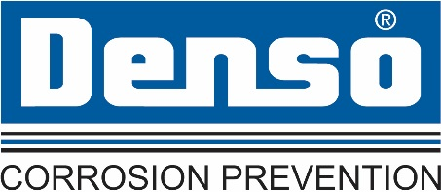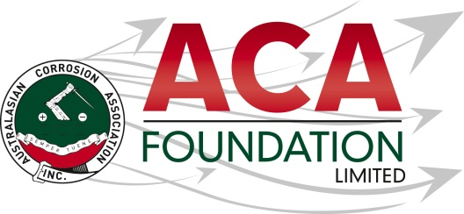

**Denso Australia**

**Student ACA Conference Attendance Scholarship**

**About the Scholarship**

The purpose of this Scholarship is to support a student in the corrosion science or related field to attend the ACA conference – Corrosion and Prevention 2024. This award is open to students currently studying an undergraduate degree or Post-graduate Masters or PhD in corrosion science or a related field during 2024

**About the ACA Foundation Limited**

ACA Foundation Limited was created for the advancement of corrosion education for the benefit of the broader community. The Foundation’s range of activities focus on Scholarships and development of corrosion related educational resources.

The ACA Foundation Limited is financially supported by The Australasian Corrosion Association Inc., its various Branches and members.

**About Denso Australia**

Denso (Australia) Pty Ltd is a subsidiary of Winn & Coales International, a leading manufacturer of anti-corrosion coatings that include [Protal liquid epoxies](https://www.densoaustralia.com.au/Denso-Liquid-Coatings.aspx), [Denso petrolatum tapes](https://www.densoaustralia.com.au/Denso-Petrolatum-Tapes.aspx), [mastics](https://www.densoaustralia.com.au/Denso-Liquid-Coatings.aspx), [bitumen tapes](https://www.densoaustralia.com.au/Denso-Bitumen-Butyl-Tapes.aspx), [butyl tapes](https://www.densoaustralia.com.au/Denso-Bitumen-Butyl-Tapes.aspx), [hot applied tapes](https://www.densoaustralia.com.au/Denso-Petrolatum-Tapes.aspx), and a full line of [marine pile protection](https://www.densoaustralia.com.au/Denso-Marine-Systems.aspx) systems.

**Detailed Description of the Scholarship**

Number of Scholarships available 1

Value of each Scholarship Student conference registration plus up to AUD $1000

Scholarship application open 20 June 2024

Scholarship application close 15 August 2024

Scholarship announced 16 September 2024

The Scholarship is in the form of 1 student conference registration and reimbursable travel and accommodation expenses up to the value of AUD$1000 (GST inclusive). Payment will be provided upon receipt of proof of conference travel and accommodation related expenses.

It is expected the scholarship recipient will provide a brief report of their conference experience including an outline the following:

* Introduction of individual
* What has been the key benefit to them as a result of attending the conference?
* What will they take away from the conference for future?
* Provide thanks to their sponsors – Denso and ACAF

**Guidelines for Eligibility for the Denso Final Year Student Scholarship**

1. Currently studying an undergraduate degree or Post-graduate Masters or PhD in corrosion science or a related field during 2024. Proof of enrolment must be provided upon submission.
2. Applicant is a citizen or permanent resident of Australia or New Zealand
3. An application form must be completed and submitted to the ACA Foundation Limited by the deadline, including the following details;

* Name & Contact Details
* University Details
* Academic History
* 250 word outline in support of the application
* 2 referees
* Proof of permanent residency or citizenship

1. Applications for an ACA Foundation Limited Scholarship are made directly to the ACA Foundation.
2. Scholarships are only awarded in response to applications. If no applications have been received that the judging panel believe warrant a scholarship, then no Scholarship will be awarded.
3. The ACA Foundation Limited Scholarship judging panel will be determined by the ACA Foundation Limited Board
4. The judges reserve the right to request a brief presentation via teleconference with short listed applicants.
5. The ACA Foundation Limited Judging Panel’s decision is final.
6. The Scholarship’s shall be judged upon the following criteria:

* Ability to present a clear and concise outline
* Referee’s comments

1. Each Scholarship recipient will be contacted by the ACA Foundation and their names/images will appear in ACA and ACA Foundation Limited collateral.