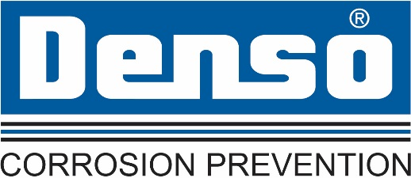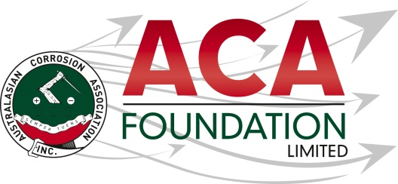

**Denso Australia**

**ACA Training Scholarship No1**

**About the Scholarship**

The purpose of this scholarship is to support the recipient with the normal cost of participating in training courses offered by ACA.This award is open to applicants from all areas of corrosion related industries including, but not limited to: asset owners/managers, material suppliers, consultants, contractors, applicators, materials scientists and engineers.

**About the ACA Foundation Limited**

ACA Foundation Limited was created for the advancement of corrosion education for the benefit of the broader community. The Foundation’s range of activities focus on scholarships and development of corrosion related educational resources.

The ACA Foundation Limited is financially supported by The Australasian Corrosion Association Inc., its various Branches and members.

**About Denso Australia**

Denso (Australia) Pty Ltd is a subsidiary of Winn & Coales International, a leading manufacturer of anti-corrosion coatings that include [Protal liquid epoxies](https://www.densoaustralia.com.au/Denso-Liquid-Coatings.aspx), [Denso petrolatum tapes](https://www.densoaustralia.com.au/Denso-Petrolatum-Tapes.aspx), [mastics](https://www.densoaustralia.com.au/Denso-Liquid-Coatings.aspx), [bitumen tapes](https://www.densoaustralia.com.au/Denso-Bitumen-Butyl-Tapes.aspx), [butyl tapes](https://www.densoaustralia.com.au/Denso-Bitumen-Butyl-Tapes.aspx), [hot applied tapes](https://www.densoaustralia.com.au/Denso-Petrolatum-Tapes.aspx), and a full line of [marine pile protection](https://www.densoaustralia.com.au/Denso-Marine-Systems.aspx) systems.

**Detailed Description of the Scholarship**

Number of Scholarships available 1

Value of each Scholarship $2,000 contribution to ACA training course

Scholarship application open 20 June 2023

Scholarship application close 15 August 2023

Scholarship announced 16 September 2023

The Scholarship is in the form of a A$2,000 contribution to a ACA training course.

**Guidelines for Eligibility for the ACA or NACE Corrosion Course Registration**

1. Applicant must be a member or employed by an ACA Corporate member of The Australasian Corrosion Association Inc.
2. Applicant is a citizen or permanent resident of Australia or New Zealand
3. If requested, applicants must provide a copy of their birth certificates or proof of residency/citizenship.
4. An application form must be completed and submitted to the ACA Foundation Limited by the deadline, including the following details;

* Name & Contact Details
* Company or Institution Details
* Academic & work histories
* Name of the ACA or NACE course that recipient would like to participate in
* 250 word outline in support of the application
* Letter of support from company/institution

1. Applications for an ACA Foundation Limited Scholarship are made directly to the ACA Foundation.
2. Scholarships are only awarded in response to applications. If no applications have been received that the judging panel believe warrant a scholarship, then no scholarship will be awarded.
3. The applicant must demonstrate that their employer or educational institution will support their application and participation in the Scholarship.
4. The ACA Foundation Limited Scholarship judging panel will be determined by the ACA Foundation Limited Board
5. The judges reserve the right to request a brief presentation via teleconference with short listed applicants.
6. The ACA Foundation Limited Judging Panel’s decision is final.
7. The Scholarship’s shall be judged upon the following criteria:

* Ability to present a clear and concise case for participating in an ACA course
* Relevance of the course to the applicants career aspirations and the broader corrosion community

1. Each scholarship recipient will be contacted by the ACA Foundation and their names/images will appear in ACA and ACA Foundation Limited collateral.