


Paper Title
A. Surname^{1,*}, B. Surname², C. Surname^{1,3}
¹Company/university affiliation name, State, Post/zip code, Country
² Company/university affiliation name, State, Post/zip code, Country
³ Company/university affiliation name, State, Post/zip code, Country
*Corresponding author email: asurname@company.com

ABSTRACT
The abstract should be one paragraph at most, and no more than 250 words. It should open with a very general statement describing the broad field being studied. The abstract is a summary of the entire process and article; it should convey the most important findings from across the results, discussion, and conclusion. It should avoid overly technical jargon or references. It should be treated as an advertisement or synopsis of the entire article with core conclusions. The abstract should be results-driven rather than experiment-focussed and act as a snap of key finding. In essence, an abstract should demonstrate the two what’s: ‘what has been done?’ and ‘what are the main findings?’. It is not appropriate for the abstract to contain any illustrations, figures, or tables. There should not be any references within the abstract. The abstract should be written last as a summary of the paper.
Keywords: steel, seawater, adhesive, protective coating
Note on keywords: Examples such as steel, seawater, adhesive, protective coating, etc. are example words that denote relevancy to the specific part of the industry and the content of the paper. Keywords should be complementary instead of cosmetic to the Abstract and can be used by other academics or researchers to locate and cite your paper if necessary. Abbreviations are appropriate if they are known industry-wide; otherwise, they are to be avoided where possible. The maximum number of keywords allowed is 5.

Introduction
The Introduction is a brief overview of the paper itself. It should not incorporate any specific experimental detail or conclusive evidence. The opening sentences often state the general topic of the work and indicate why this work is important. The introduction should provide an overview and general background for the reader to understand the intention of the paper. Often the introduction will finish with a paragraph that briefly explains what the authors will discuss in the rest of the paper as to what they have done in relation to the general topic of interest.
The introduction may include historical precedents on the matter, such as relevant prior studies on the subject matter or a broader description of the industry, discipline, or topic. This section shouldn’t be extensive as long or overly detailed introductions tend to dissuade the reader from becoming immersed in the body of the article.
At most, the introduction should convey a broader picture of the topic at hand and what the writer intends to discuss. As previously mentioned, the general statement of purpose should be included in the last section, preferably the final sentence, of the introduction. The hypothesis and objectives should be clearly stated at the end of the introduction with any pertinent conclusion details, though it is not essential to describe them as hypotheses or objectives, as this should be implicit. It is appropriate for there to be links between the introduction, the abstract and the keywords section; as such, similar words, and phrasing lead into the remaining sections.
Don’t introduce major ideas or findings that aren’t discussed later in the paper. The introduction should further state what the topic is and why it is worthy of an academic paper. This can include further conclusions from previous research, gaps in the outcomes developed from the research of the paper being presented and provides a more detailed overview elaborating on the abstract.
This document will provide a general guide on how to structure and format a paper for the Australasian Corrosion Association (ACA) conference. This is provided in a Word document format to hopefully make life easier for authors. It is hard to provide a guide that covers every possible aspect and type of paper, so if you have any queries and/or comments please contact the ACA office to follow this up.

Referencing
As a general rule, it is discouraged to directly quote an author; it is considered better academic practice to reword the original author’s research, ideas, and findings in your own words and reference it accordingly. Any research, ideas, or finding that that are not your own must be substantiated in the text; if in doubt, always reference, it is better than accusations of plagiarism. Any figure that contains another author’s work must be cited in the text section of the results section, with the corresponding text and figure relationship clearly conveyed. The number of references included will depend on the work being reported, but as a rough guide it is not recommended to have in excess of 40 references for a conference paper, unless they are absolutely necessary to support findings.
All references must be provided in the Reference section near the end of the paper. Referencing must be consistent with appropriate academic guidelines. In the text you may want to use references if in line with the discipline. Do not mix reference styles in the one paper - use the same consistent system with the appropriate bibliography. The footnotes and in-text citations should additionally be appropriate.
It is recommended to use a numerical in-text citation style. Some examples of this would be:
- One of the earliest reports of the effect of salt on the corrosion of magnesium was the work of Bruce and Smith [1]. In their paper they showed …
- Investigations on the effect of salt on the corrosion of magnesium first began in the 1970’s [1, 2].
- If there are more than two papers to be referenced show them like this [5 – 8].
The reference at the end would then contain the details of the paper, such as:
- Bruce AR. and Smith B., Name of the article cited, Name of the Journal cited vol. number of the journal (issue number of the journal), (year), page start – page end.
Examples of style guides for the referencing of different types of information sources are provided in the References section towards the end of the document. If possible, you can attach the Digital Object Identifier (DOI) for a journal, though this is not mandatory.

Trade Names
It is the policy of the ACA that generic names must be used in place of Trade names. Where appropriate, a Trade name may be used ONCE in the text of the paper and must be identified with a footnote giving the source of the Trade name. If they have been assigned, Unified Numbering System (UNS) numbers, specification numbers, generic names or chemical compositions shall be used in place of material trade names. Trade names shall not appear in the title, abstract, tables, figures, or captions.
IMPORTANT: Papers that contain improperly used Trade names will be returned to the author for correction. Final approval from the Conference Technical Committee shall not be given unless Trade name use conforms with these guidelines. In addition, papers which are overtly commercial in nature will be returned to the author for rectification. Final approval from the Technical Committee shall not be given unless the all marketing hyperbole and other overtly commercial content has been removed or otherwise neutralised.

Methods and Materials
Please use the same names of the main section titles (e.g., Introduction, Methods and Materials, etc.) as specified in this template where possible. It is acceptable for a paper that requires an alternative structure for section designation to have this as long as it is practical and follows the remaining conventions and frameworks of this paper template.

Sub-section Heading 2
Text for this section if needed. Sub-section titles can be named as the author deems appropriate.

Heading 3
Insert details of any materials or methods used in experiments or part of the reported work here. As a rule of thumb include enough information that would be needed for a reader to be able to repeat the reported work. If utilising or referring to existing and/or established experiments, make sure that they are referenced. This can include pre-emptive considerations prior to the experiment, such as what were the driving interests or motivations of the experiment, or what the hypothesis was of an anticipated outcome. This would also include any methods implemented to get the most accurate results.
Do not incorporate obscure or proprietary chemicals or applications that may be impenetrable for the reader. When using units of measurement, utilise the same standards throughout the entire paper; moving between different units of measurements is unnecessarily confusing.
This section should be descriptive; it should detail the nature of the methods that were employed to obtain the results. This should not be step-by-step and should remain in the passive voice. However, for an experimental-based paper, this detail should be detailed enough so that another researcher can replicate your results, and separate experiments should be separated in detail. Where possible consider providing a diagram or photo of the experimental/test arrangement to help the reader. For field studies, this method section should outline approaches taken to obtain the resulting observation.

Results
Text describing any results should be inserted here. There may be an assumption that some readers of a paper will skip or skim over the method to get the results; with this in mind, it is worth including a broad outline of the method prior to commencing on the results to avoid a disconnect in the reader’s understanding of the paper. This is to provide conceptual tools to understand the results; it should not be an entire rehash of the method as discussed in detail in the prior section.
The results should flow as a story; it is assumed that there was a presumption or contention that drove the research and method before generating results that can be reflected upon. There should be stress upon the key results; they are to be presented as the primary focus, with secondary or support findings and data being detailed afterwards. It is generally acceptable to include some level of discussion within this section; for example, it is appropriate to draw conclusions based on how the results compare with an academic precedent. However, do not present results until after the explanation as to how they were obtained. And what they mean or show.
Text can be complemented by tables, figures, diagrams, equations, or any other relevant display of data. Below are examples of a table, figures and an equation to be used within the text, together with recommended spacing before and after. All figures and/or diagrams should have a resolution of 600 DPI.

Example of a Table
Tables can use as many columns as necessary, as long as they are relevant and applicable to the study. To help make tables and figures stand out from the text please add a blank line before and after the table/figure. Where possible tables should be kept on the same page for clarity.
Table 1. Table Caption
Advantages | Disadvantages
Lower manufacturing cost | Relatively low shear and peel resistance
Forgiving to surface preparation | Limited to small diameter pipes (<660 mm)
Good C.D. resistance | Limited to small diameter pipes (<660 mm)
Excellent water repellents | Limited to small diameter pipes (<660 mm)

You can add other tables by copying this one to a new place in the paper and modifying it by overtyping text, deleting columns or rows or adding them using the Table pull-down menu. Tables can be more or less elaborate based on the tenets of the experiment conveyed.

Example of Figure or Diagram
Figures and diagrams should be placed in a table, with the border removed. To do this, go to Docs, click the Format pull-down menu. Click Borders and Shading and remove them. Paste the first figure here - it will occupy the space as best it can, but you may have to adjust its size to suit the page and the adjacent figure. Use the handles (small squares) at the corners of the photo or diagram to ensure the aspect ratio remains the same. Click on the figure at right to see these handles.
Authors need to ensure that all figures and tables are referred to in the text, e.g., “Figure 1 shows the …”. Where possible try to insert figures and tables in the text close to where they are referred to. However, try to avoid this causing large areas of blank white space at the bottom of a page. If this happens you may need to shift the position of the figure or table to slightly later in the paper. Ensure that numbers are reported with appropriate significant figure accuracy.
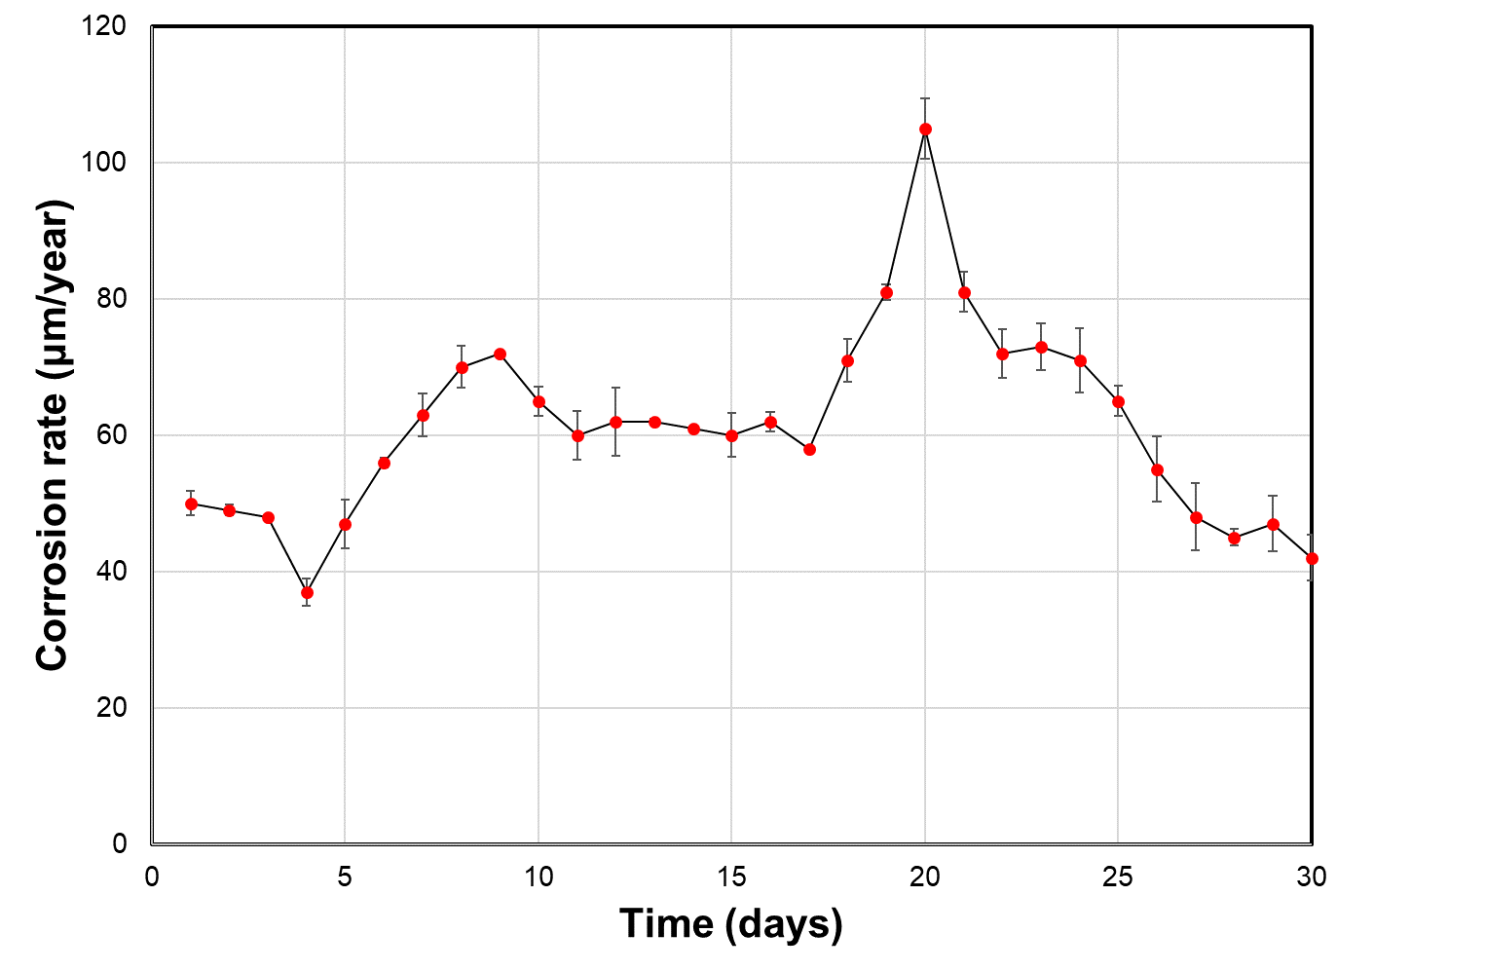
Figure 1: Put the Figure Caption here

If there are more figures associated with a particular result (see Figure 2) paste them in the box/column adjacent where possible. Use standard formats (such as JPEG or PNG) for photographs and figures. Make sure that there is a blank (like shown) above and below figures. Repeat as required for other photographs or diagrams. It is best to draw diagrams separately and save them as separate documents and only then paste them in as whole units.
When creating figures, try to make sure that the font sizes used are clearly legible and of a similar size to the main text in the document when the figure is inserted and resized. Figure captions should provide sufficient information about the figure for the reader to generally understand without having to refer to the main text of the paper.
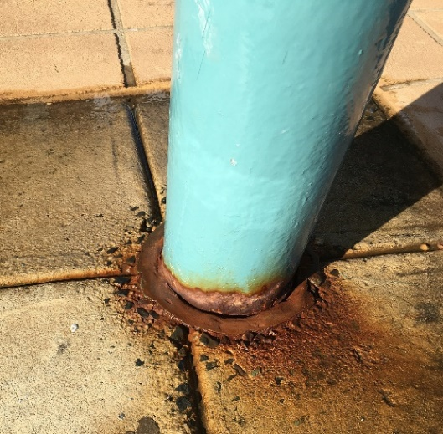 | 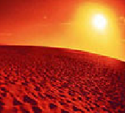
(a) | (b)
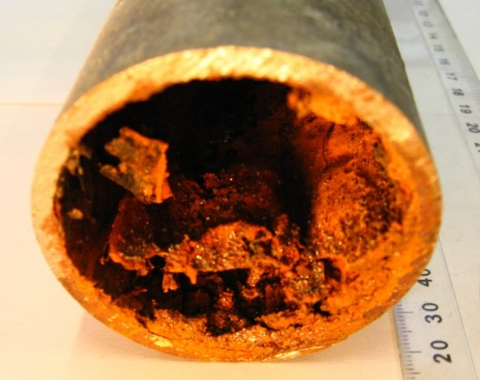 | 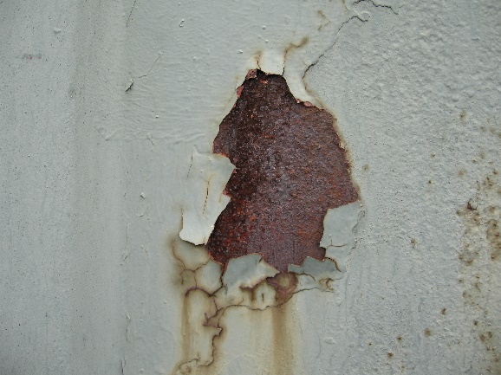
(c) | (d)
Figure 2: Put the figure caption here (a) shows…., (b) shows …., …

Example of an equation
When equations are used in the paper, they may be created using the MS-Word Equation Editor. You obtain it by clicking on Insert. Click Object and then Equation Editor. All equations should be on a separate line, centred and with a sequential number at right, commencing at (1). All of the variables of an equation need to be defined in the main text body.
$A=πr^{2}$ (1)

Discussion
Discussions and interpretation of any results found are displayed here. The discussion acts as a successor to and feeds from the results as derived from the experimental and/or method. The discussion should correspond to and reflect on results; it should not however reiterate the results in detail. Results should be put in context with any previous work on the topic, which should be referenced.
This part of the paper demonstrates the major findings. It can also discuss the shortcomings of the results, what avenues are to be pursued in future, and what the immediate implications of the findings are. Quantitative descriptions are still appropriate; the discussion must maintain its empirical bent. No new results are to be introduced in the discussion.
The discussion section can also include any perceived or anticipated repudiations upon the author’s findings or contentions. These objections can be as specific or broad as needed to support the author’s view. Further, the author can suggest areas of further research for other authors to pursue following the publication of the paper, whilst noting any limitations, prior to another researcher’s studying.
Speculations or inconclusive results should be separate from the findings and be clearly delineated; this should be towards or at the end of the paper to avoid it receiving more attention than the more conclusive outcomes. However, any speculation must be rooted more in fact than imagination.

Conclusions
Conclusions and recommendations can be included here. This section should be brief (approximately one paragraph) and shouldn’t include any new statistical information or contentions outside of what has already been suggested within the discussion. The conclusion should restate the paper’s contention, reiterate your main evidence, and summarise the paper’s findings. The conclusion should not reiterate the abstract; or just list the results as discussed earlier in the paper. It should tie the paper together, justifying the scientific rationale for writing the paper whilst demonstrating how the paper advances the field it was written about in terms of knowledge and discourse.

Acknowledgments
If any person or institution contributed to the final paper and are not in the list of authors, this section is to include their name, position, and role in the work reported. This is any contribution short of actual authorship. This occurs at the discretion of the author or authors. It is to be written in the first person and should retain a formal academic and/or professional tone where possible. It should be an acknowledgement and avoid outright flattery. There shouldn’t be any abbreviations, and where appropriate it should note the author’s company, school, or any broader relationship they have with a wider group. Any funding sources used to support the work should be included here.

REFERENCES
- Thompson AA, Wood JL, Palombo EA, Green WK and Wade SA, From laboratory tests to field trials: a review of cathodic protection and microbially influenced corrosion, Biofouling 38(3) (2022) 298-320.
- Guiqiao H and Peng G, Effect of environment factors on corrosion rate of steel, (In) Proc. 16th Intl. Corrosion Congress, Sept 19-24, 2005, Beijing, China, Paper 23.
- Evans UR, The corrosion and oxidation of metals: Scientific principles and practical applications, Edward Arnold (Publishers) Ltd., London, 1960.
- Eckert RB and Amend B, MIC and Materials Selection, (In) Microbiologically Influenced Corrosion in the Upstream Oil and Gas Industry (Ed) T Lund Skovhus, D Enning and J Lee, CRC Press, Boca Raton, 2017, 35-56.
- Report of Committee B-3, Appendix II, Report of subgroup of subcommittee VI on corrosiveness of various atmospheric test sites as measured by specimens of steel, Proc. ASTM, 59 (1959): 183-201.
- What is Corrosion see: https://membership.corrosion.com.au/blog/what-is-corrosion/ Last accessed 26 March 2023.
- ASTM G1 – 90, Standard Practice for Preparing, Cleaning, and Evaluating Corrosion Test Specimens

Note: the above references are examples of work reported in:
¹Journal paper
²Conference paper
³Book
⁴Chapter from a book
⁵Technical/research report
⁶Web reference
⁷Standard

AUTHOR DETAILS
Photos are to be submitted in 600 DPI. One of the authors should be nominated as the corresponding author in case of feedback or any other communication required between the author and the Conference. The corresponding author and contact details should also be clearly stated in list of authors at the start of the paper.
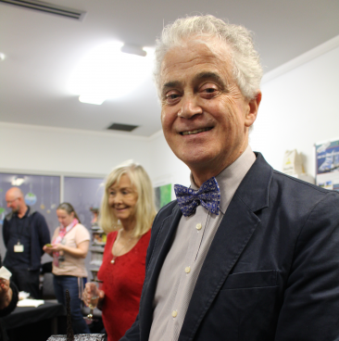 Paste a digital photo of the first author here. | A. Surname is the corresponding author of this paper. She/he is an Occupation at Company/Association, a position he/she/they has held since the starting year. He/she/they is/are responsible for the job responsibilities and accountabilities - No more than 75 words please.
Paste a digital photo of the second author here, about 50 mm wide x 50mm high.  For additional authors add row(s) using the TABLE pull-down menu | B. Surname is the Occupation at Company/Association, a position he/she/they has held since the starting year. He/she/they is/are responsible for the job responsibilities and accountabilities - No more than 75 words please.

