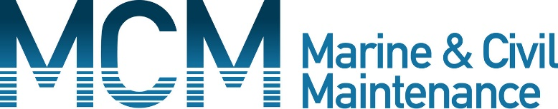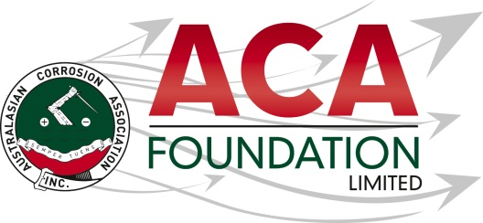

**Marine & Civil Maintenance (MCM)**

**Professional ACA Conference Attendance 2025 Scholarship**

**About the Scholarship**

The purpose of this Scholarship is to support an individual who is an industry professional and would otherwise be unable to attend the annual ACA conference – Corrosion & Prevention 2025 without sponsorship. This award is open to applicants from all areas of corrosion related industries including, but not limited to; asset owners/managers, material suppliers, consultants, contractors, applicators, materials scientists and engineers.

**About the ACA Foundation Limited**

ACA Foundation Limited was created for the advancement of corrosion education for the benefit of the broader community. The Foundation’s range of activities focus on Scholarships and development of corrosion related educational resources.

The ACA Foundation Limited is financially supported by The Australasian Corrosion Association Inc., its various Branches and members.

**About Marine and Civil Maintenance**

MCM are an industry leader in the repair and maintenance of complex infrastructure assets throughout Australia and the Pacific. Our specialist services allow us to work innovatively across a number of sectors including Water, Transport, Marine, Buildings and Industrial & Mining.

**Detailed Description of the Scholarship**

Number of Scholarships available 1

Value of each Scholarship $2,500

Scholarship application open 1 July 2025

Scholarship application close 15 August 2025

Scholarship announced 15September 2025

The Scholarship is in the form of a A$2,500 contribution to attendance at the ACA annual conference or an ACA training course.

It is expected the scholarship recipient will provide a brief report of their conference experience including an outline the following:

* Introduction of individual
* What has been the key benefit to them as a result of attending the conference?
* What will they take away from the conference for future?
* Provide thanks to their sponsors – MCM and ACAF

**Guidelines for Eligibility for the Denso Professional Scholarship**

1. Applicant is a citizen or permanent resident of Australia or New Zealand
2. If requested, applicants must provide a copy of their birth certificates or proof of residency/citizenship.
3. An application form must be completed and submitted to the ACA Foundation Limited by the deadline, including the following details;

* Name & Contact Details
* Company/Institution Details
* Academic, conference/courses and work histories
* 250 word outline in support of the application
* Letter of support from company/institution
* 2 referees

1. Applications for an ACA Foundation Limited Scholarship are made directly to the ACA Foundation.
2. Scholarships are only awarded in response to applications. If no applications have been received, that the judging panel believe warrant a Scholarship, then no Scholarship will be awarded.
3. The applicant must demonstrate that their employer or educational institution will support their application and participation in the Scholarship.
4. The ACA Foundation Limited Scholarship judging panel will be determined by the ACA Foundation Limited Board
5. The judges reserve the right to request a brief presentation via teleconference with short listed applicants.
6. The ACA Foundation Limited Judging Panel’s decision is final.
7. The Scholarship’s shall be judged upon the following criteria:

* Ability to present a clear and concise case
* Referee’s comments
* ACA Foundation’s focus on access, equity and participation

1. Each Scholarship recipient will be contacted by the ACA Foundation and their names/images will appear in ACA and ACA Foundation Limited publications.