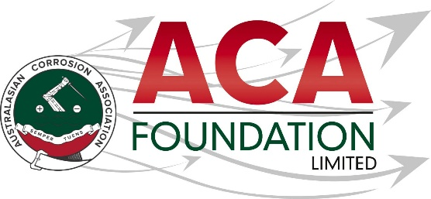
2026 – Carboline NZ
ACA Training Course or Conference attendance Scholarship

About the ACA Foundation
The ACA Foundation Limited (ACAF) is the charitable arm of the ACA, dedicated to advancing corrosion education and promoting corrosion control in the community. As a not-for-profit entity, all funds generated by the Foundation are reinvested into the corrosion community through scholarships, training and educational programs.

The ACA Foundation is financially supported by The Australasian Corrosion Association Limited (ACA), its various Branches and members, and its sponsors.

About the Scholarship
The purpose of this Scholarship is to support a New Zealand based individual who is involved in the protective coatings industry, to attend an ACA Training course or the ACA annual conference. This award is open to applicants from all areas of the construction and/or corrosion related industries including, but not limited to asset owners/managers, materials suppliers, consultants, contractors, students, scientists and engineers.

About Carboline NZ
Carboline is a global supplier of coatings, linings, and fireproofing with offices and manufacturing facilities worldwide. They have a strong commitment to the protective coatings industry and take an active role in professional organizations that focus on corrosion control, water transmission, and fire protection. They are committed to progressing science for the future of the coatings industry.

Carboline NZ is a Division of Altex Coatings, a New Zealand based company who specialise in the formulation, manufacture, and specification of high performance industrial and marine protective coatings throughout Australasia and Southern Pacific regions. For more information refer to Carboline Australia-New Zealand

Detailed Description of the Carboline NZ Scholarship
Number of Scholarships available 1
Value of Scholarship NZ$2,500
Scholarship application open 15 April 2026
Scholarship application closes 30 June 2026
Scholarship announced 31 July 2026

The Scholarship is in the form of a $2,500 contribution towards costs to attend the ACA annual conference or an ACA arranged training course.
Please note.
It is expected the scholarship recipient will provide a brief report on their conference/training experience including an outline of the following:
- Introduction of individual
- What has been the key benefit to them as a result of attending the conference/training course?
- What will they take away from this for their future?
- Provide thanks to their sponsors – Carboline NZ and ACAF

Guidelines for Eligibility for the Carboline NZ Scholarship
- Applicant is a citizen or permanent resident of New Zealand
- If requested, applicants must provide a copy of their birth certificates or proof of residency/citizenship.
- An application form must be completed and submitted to the ACA Foundation by the deadline, including the following details.
- Name & Contact Details
- Company/Institution Details
- Academic, conference/courses and work histories
- 250-word outline in support of the application
- Letter of support from company/institution and two creditable referees

- Applications for an ACAF Scholarship are made directly to the ACA Foundation.

- Scholarships are only awarded in response to applications. If no applications have been received, then no Scholarship will be awarded.

- The applicant must demonstrate that their employer or educational institution will support their application and participation in the Scholarship.

- The ACAF Scholarship Judging Panel will be determined by the ACAF Board and their decision is final.

- The judges reserve the right to request a brief presentation via teleconference with shortlisted applicants if deemed necessary.

- The Scholarship’s shall be judged upon the following criteria:
- Ability to present a clear and concise case
- Referee’s comments
- ACA Foundation’s focus on access, equity, and participation

- Each Scholarship recipient will be contacted by the ACA Foundation, and their names/images may appear in ACA and ACAF publications.

- Payment will be arranged by ACA NZ Branch Inc. on receipt of relevant invoices following attendance at conference or the training course.

- Successful applicants are encouraged to attend the conference to receive their award and then provide their appreciation to their sponsor soon after it is used.

