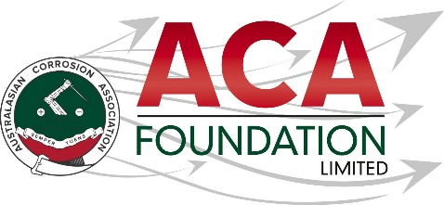

2026 -Metspray
ACA Training Course or Conference attendance Scholarship

About the ACA Foundation

The ACA Foundation Limited (ACAF) is the charitable arm of the ACA, dedicated to advancing corrosion education and promoting corrosion control in the community.
As a not-for-profit entity, all funds generated by the Foundation are reinvested into the corrosion community through scholarships, training and educational programs.
The ACA Foundation is financially supported by The Australasian Corrosion Association Limited (ACA), its various Branches and members.

About the Scholarship

The purpose of this Scholarship is to support an individual who is involved in the protective coatings industry, to attend an ACA Training course or the ACA annual conference. This award is open to applicants from all areas of the industry including, but not limited to, industrial coating contractors management and staff, materials suppliers, and protective coating inspectors or specifiers.

About our sponsor Metspray

Metspray (NZ) 2013 Ltd is a full-service industrial coatings company based in East Tamaki, Auckland. With both shop and site capabilities, they specialize in the application of high-performance industrial coatings and intumescent coatings, providing long term protection from corrosion and/or fire for structural steel or equipment. For more information refer to www.metspray.co.nz

Detailed Description –
Number of Scholarships available 1
Value of Scholarship NZ$2,500
Scholarship application open 15 April 2026
Scholarship application closes 30 June 2026
Scholarship announced 31 July 2026

The Scholarship is in the form of a NZ$2,500 contribution towards attendance at the ACA annual conference or an ACA training course.

Please note.
It is expected the scholarship recipient will provide a brief report on their conference experience including an outline of the following:
- Introduction of individual
- What has been the key benefit to them as a result of attending the conference?
- What will they take away from the conference for future?
- Provide thanks to their sponsors – Metspray and ACAF

Guidelines for Eligibility for the Metspray Scholarship
- Applicant is a citizen or permanent resident of New Zealand
- If requested, applicants must provide a copy of their birth certificates or proof of residency/citizenship.
- An application form must be completed and submitted to the ACA Foundation by the deadline, including the following details.
- Name & Contact Details
- Company/Institution Details
- Academic, conference/courses and work histories
- 250-word outline in support of the application
- Letter of support from company/institution
- Two creditable referees

- Applications for an ACAF Scholarship are made directly to the ACA Foundation.

- Scholarships are only awarded in response to applications. If no applications have been received, then no Scholarship will not be awarded.

- The applicant must demonstrate that their employer or educational institution will support their application and participation in the Scholarship.

- The ACAF Scholarship judging panel will be determined by the ACAF Board

- The judges reserve the right to request a brief presentation via teleconference with shortlisted applicants if deemed necessary.

- The ACA Foundation’s Judging Panel’s decision is final.

- The Scholarship’s shall be judged upon the following criteria:
- Ability to present a clear and concise case
- Referee’s comments
- ACA Foundation’s focus on access, equity, and participation

- Each Scholarship recipient will be contacted by the ACA Foundation, and their names/images will appear in ACA and ACAF publications.
- Payment will be arranged by ACA NZ Branch Inc. on receipt of relevant invoices following attendance at conference or the training course.

- Successful applicants are expected to attend the conference to receive their award and then provide their appreciation to their sponsor soon afterwards te.

