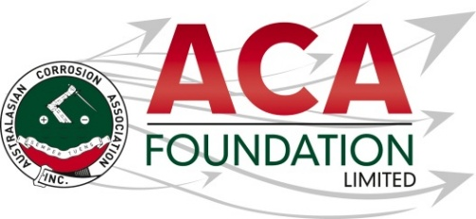


2026 BlastOne Australia
AMPP Training Course Scholarship

About the Scholarship
The purpose of this Scholarship is to support the successful candidate to attend a AMPP training course. This award is open to applicants from all areas of the corrosion industry.

About the ACA Foundation Limited
ACA Foundation Limited was created for the advancement of corrosion education for the benefit of the broader community. The Foundation’s range of activities focus on Scholarships and development of corrosion related educational resources.

The ACA Foundation Limited is financially supported by The Australasian Corrosion Association Ltd, its various Branches and members.

About BlastOne Australia
BlastOne Australia is a leading supplier of abrasive blasting, protective coating, and surface preparation solutions serving industries such as mining, marine, oil and gas, infrastructure, and manufacturing. Founded in Australia in 1975, the company provides advanced blasting equipment, abrasives, robotic automation systems, and industrial coating technologies designed to improve productivity, safety, and corrosion control. BlastOne is recognized for its technical expertise, engineering support, and innovation in high-performance blast and paint facilities across Australia and globally. With operations spanning multiple countries, the company focuses on helping industrial contractors complete projects faster, safer, and cleaner through integrated equipment, training, and engineering solutions. For more information go to BlastOne

Detailed Description of the Scholarship
Number of Scholarships available 1
Value of each Scholarship AUD$2,500
Scholarship application open 1 June 2026
Scholarship application close 31 July 2026
Scholarship announced 1 September 2026

The Scholarship is in the form of a AUD$2,500 contribution towards attendance at the AMPP training course.

It is expected the scholarship recipient will provide a brief report of their experience including an outline of the following:
- Introduction of individual
- What has been the key benefit?
- What will they take away from experience for the future?
- Provide thanks to their sponsors – BlastOne Australia and ACAF

Guidelines for Eligibility for the BlastOne Australia Scholarship
- Applicant is a citizen or permanent resident of Australia
- If requested, applicants must provide a copy of their birth certificates or proof of residency/citizenship.
- An application form must be completed and submitted to the ACA Foundation Limited by the deadline, including the following details.
- Name & Contact Details
- Company/Institution Details
- Academic, conference/courses and work histories
- 250 word outline in support of the application
- Letter of support from company/institution
- 2 referees

- Applications for an ACA Foundation Limited Scholarship are made directly to the ACA Foundation.
- Scholarships are only awarded in response to applications. If no applications have been received, that the judging panel believe warrant a Scholarship, then no Scholarship will be awarded.
- The applicant must demonstrate that their employer or educational institution will support their application and participation in the Scholarship.
- The ACA Foundation Limited Scholarship judging panel will be determined by the ACA Foundation Limited Board
- The judges reserve the right to request a brief presentation via teleconference with shortlisted applicants.
- The ACA Foundation Limited Judging Panel’s decision is final.
- The Scholarship’s shall be judged upon the following criteria:
- Ability to present a clear and concise case
- Referee’s comments
- ACA Foundation’s focus on access, equity, and participation
- Each Scholarship recipient will be contacted by the ACA Foundation and their names/images will appear in ACA and ACA Foundation Limited publications.
- Payment will be arranged by ACA Inc. on receipt of relevant invoices following attendance.

