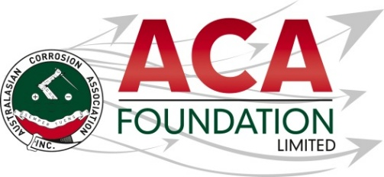


2026 Concrete Preservation Technologies
Post Graduate Student Scholarship for training in the corrosion field

About the Scholarship
The purpose of this Scholarship is to support a postgraduate student to attend a certified training course in the corrosion field. This award is open to applicants from all areas of the corrosion industry.

About the ACA Foundation Limited
ACA Foundation Limited was created for the advancement of corrosion education for the benefit of the broader community. The Foundation’s range of activities focus on Scholarships and development of corrosion related educational resources.

The ACA Foundation Limited is financially supported by The Australasian Corrosion Association Ltd, its various Branches and members.

About Concrete Preservation Technologies
With over 80 years of combined experience in concrete repair consultancy and over 60 years of experience in the electro-chemical treatment of reinforced concrete structures. They have a knowledgeable sales, production, and R&D teams, and distributor partners, all dedicated to ensuring customer satisfaction and delivering high quality, industry leading products. UK based manufacturer of cutting edge corrosion control solutions for a wide range of structures including bridges, car parks, jetties and concrete framed buildings. There unique, compact and powerful corrosion control systems have been installed on over 500 projects worldwide, including in Australia, the USA and the UAE. For more information go to https://cp-tech.co.uk/

Detailed Description of the Scholarship
Number of Scholarships available 1
Value of each Scholarship AUD$2,500
Scholarship application open 1 June 2026
Scholarship application close 31 July 2026
Scholarship announced 1 September 2026

The Scholarship is in the form of a AUD$2,500 contribution towards attendance at the certified corrosion training.

It is expected the scholarship recipient will provide a brief report of their experience including an outline of the following:
- Introduction of individual
- What has been the key benefit?
- What will they take away from experience for the future?
- Provide thanks to their sponsors – Concrete Preservation Technologies and ACAF

Guidelines for Eligibility for the Concrete Preservation Technologies Scholarship
- Applicant is a citizen or permanent resident of Australia
- If requested, applicants must provide a copy of their birth certificates or proof of residency/citizenship.
- An application form must be completed and submitted to the ACA Foundation Limited by the deadline, including the following details.
- Name & Contact Details
- Company/Institution Details
- Academic, conference/courses and work histories
- 250 word outline in support of the application
- Letter of support from company/institution
- 2 referees

- Applications for an ACA Foundation Limited Scholarship are made directly to the ACA Foundation.
- Scholarships are only awarded in response to applications. If no applications have been received, that the judging panel believe warrant a Scholarship, then no Scholarship will be awarded.
- The applicant must demonstrate that their employer or educational institution will support their application and participation in the Scholarship.
- The ACA Foundation Limited Scholarship judging panel will be determined by the ACA Foundation Limited Board
- The judges reserve the right to request a brief presentation via teleconference with shortlisted applicants.
- The ACA Foundation Limited Judging Panel’s decision is final.
- The Scholarship’s shall be judged upon the following criteria:
- Ability to present a clear and concise case
- Referee’s comments
- ACA Foundation’s focus on access, equity, and participation
- Each Scholarship recipient will be contacted by the ACA Foundation and their names/images will appear in ACA and ACA Foundation Limited publications.
- Payment will be arranged by ACA Inc. on receipt of relevant invoices following attendance.

