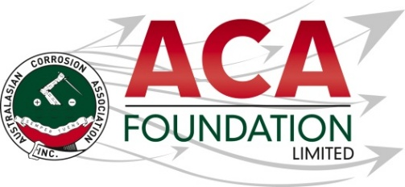


2026 Denso Australia
Student training in the corrosion field

About the Scholarship
The purpose of this Scholarship is to support a student in further training the corrosion field. This award is open to applicants from all areas of the corrosion industry.

About the ACA Foundation Limited
ACA Foundation Limited was created for the advancement of corrosion education for the benefit of the broader community. The Foundation’s range of activities focus on Scholarships and development of corrosion related educational resources.

The ACA Foundation Limited is financially supported by The Australasian Corrosion Association Ltd, its various Branches and members.

About Denso Australia
Over the last 90 years, Denso have been creating bespoke and off-the-shelf solutions that provide enduring protection against corrosion and chemical attack to buried and exposed pipes, valves, fittings, steelwork, marine structures, tanks and concrete bunded areas.

From sub-zero environments to extreme high temperatures, our range of products are capable of withstanding the toughest conditions, as well as proving to be cost-effective and maintenance free for several years. For more information got to https://densoaustralia.com.au/

Detailed Description of the Scholarship
Number of Scholarships available 1
Value of each Scholarship AUD$2,500
Scholarship application open 1 June 2026
Scholarship application close 31 July 2026
Scholarship announced 1 September 2026

The Scholarship is in the form of a AUD$2,500 contribution towards attendance at corrosion related training course training course.

It is expected the scholarship recipient will provide a brief report of their experience including an outline of the following:
- Introduction of individual
- What has been the key benefit?
- What will they take away from experience for the future?
- Provide thanks to their sponsors – Denso Australia and ACAF

Guidelines for Eligibility for the Denso AustraliaScholarship
- Applicant is a citizen or permanent resident of Australia
- If requested, applicants must provide a copy of their birth certificates or proof of residency/citizenship.
- An application form must be completed and submitted to the ACA Foundation Limited by the deadline, including the following details.
- Name & Contact Details
- Company/Institution Details
- Academic, conference/courses and work histories
- 250 word outline in support of the application
- Letter of support from company/institution
- 2 referees

- Applications for an ACA Foundation Limited Scholarship are made directly to the ACA Foundation.
- Scholarships are only awarded in response to applications. If no applications have been received, that the judging panel believe warrant a Scholarship, then no Scholarship will be awarded.
- The applicant must demonstrate that their employer or educational institution will support their application and participation in the Scholarship.
- The ACA Foundation Limited Scholarship judging panel will be determined by the ACA Foundation Limited Board
- The judges reserve the right to request a brief presentation via teleconference with shortlisted applicants.
- The ACA Foundation Limited Judging Panel’s decision is final.
- The Scholarship’s shall be judged upon the following criteria:
- Ability to present a clear and concise case
- Referee’s comments
- ACA Foundation’s focus on access, equity, and participation
- Each Scholarship recipient will be contacted by the ACA Foundation and their names/images will appear in ACA and ACA Foundation Limited publications.
- Payment will be arranged by ACA Inc. on receipt of relevant invoices following attendance.

