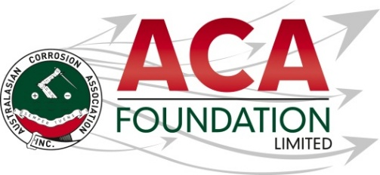


Postgraduate Scholarship - conference attendance or training in the corrosion field

About the ACA Foundation Limited
ACA Foundation Limited was created for the advancement of corrosion education for the benefit of the broader community. The Foundation’s range of activities focus on Scholarships and development of corrosion related educational resources.

The ACA Foundation Limited is financially supported by The Australasian Corrosion Association Ltd, its various Branches and members.

About Infracorr
Infracorr Consulting Pty. Ltd is a mission-driven, industry leader in structural repair and durability services. The principal areas of expertise include maximising the longevity of structural assets with innovative condition assessment and design solutions.
They invest in techniques that aim for cost-efficiency by utilising state-of-the-art non-destructive tools to investigate and remotely monitor repair and protection.
They ensure that ageing and deteriorating assets, whether large or small, are repaired and/or protected with a design that meets the life expectancy required. They take pride in achieving these results with solutions designed to optimise cost and disruption to businesses and their stakeholders. They have a team of highly skilled engineers, technicians and researchers combining decades of experience to help preserve and prolong the life of existing structures and make new projects last a lifetime. For more information go to https://www.infracorr.com

Detailed Description of the Scholarship
Number of Scholarships available 1
Value of each Scholarship AUD$2,500
Scholarship application open 1 June 2026
Scholarship application close 31 July 2026
Scholarship announced 1 September 2026

The Scholarship is in the form of a AUD$2,500 contribution towards training or conference attendance.

It is expected the scholarship recipient will provide a brief report of their experience including an outline of the following:
- Introduction of individual
- What has been the key benefit?
- What will they take away from experience for the future?
- Provide thanks to their sponsors – Infracorr and ACAF

Guidelines for Eligibility for the Infracorr Scholarship
- Applicant is a citizen or permanent resident of Australia
- If requested, applicants must provide a copy of their birth certificates or proof of residency/citizenship.
- An application form must be completed and submitted to the ACA Foundation Limited by the deadline, including the following details.
- Name & Contact Details
- Company/Institution Details
- Academic, conference/courses and work histories
- 250 word outline in support of the application
- Letter of support from company/institution
- 2 referees

- Applications for an ACA Foundation Limited Scholarship are made directly to the ACA Foundation.
- Scholarships are only awarded in response to applications. If no applications have been received, then no Scholarship will be awarded.
- The applicant must demonstrate that their employer or educational institution will support their application and participation in the Scholarship.
- The ACA Foundation Limited Scholarship judging panel will be determined by the ACA Foundation Limited Board
- The judges reserve the right to request a brief presentation via teleconference with shortlisted applicants.
- The ACA Foundation Limited Judging Panel’s decision is final.
- The Scholarship’s shall be judged upon the following criteria:
- Ability to present a clear and concise case
- Referee’s comments
- ACA Foundation’s focus on access, equity, and participation
- Each Scholarship recipient will be contacted by the ACA Foundation and their names/images will appear in ACA and ACA Foundation Limited publications.
- Payment will be arranged by ACA Inc. on receipt of relevant invoices following attendance.

