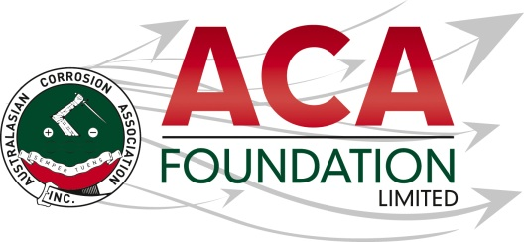

2026 Mike Rutherford Memorial Training Award Sponsored by the ACA Foundation Centurions

Applicant Details

Title:
First Name:
Last Name:

Company:
Job Title:
Address:

Suburb
City |  | Postcode
Country:
Work Phone: |  | Mobile:
Email:
ACANZ Member? Y/N

- Employment History, academic career & courses attended

List employment history, the last 10 years if available

Position | Organisation/Institution | From | To

List qualifications
Qualification | Class Level | Institution | Year Awarded

List conferences that you have attended or courses/training that you have completed
Name of Conference/Course | Institution or Organisation offering the Conference/Course | Year Attended

- Referees

Please provide the names and contact details of 2 referees who can be approached by ACA Foundation Limited.

Referee One

Title:
First Name:
Last Name:

Company or Institution:
Job Title:
Address:

Suburb
City |  | Postcode
Country:
Work Phone: |  | Mobile
Email:

Referee Two

Title:
First Name:
Last Name:

Company or Institution:
Job Title:
Address:

Suburb
City |  | Postcode
Country:
Work Phone: |  | Mobile
Email:
ACA Member? Y/N

- Supporting Documentation

Please also provide a 250-word outline to support the application including your career ambitions and reasons for wanting to participate in corrosion related activities and training specified in the scholarship.
If you are completing this form electronically, please cut and paste your outline into the box below. If you are submitting a hard copy of this application, please attach your outline to your application.

- Letter of support
Please provide a letter of support from your employer or academic institution supporting this Scholarship application.

All the information given in this Scholarship application is factual and correct at the time of submission; I understand that incorrect information may render this application void.
I understand and accept that all documentation published by ACA Foundation Limited is part of the total application information package.

I understand and accept all terms and conditions attached to the awarding of the Scholarship by ACA Foundation Limited and that all decisions by ACA Foundation Limited in relation to the award of this or any other scholarship, prize or bursary are final and are not subject to appeal, review or petition.

Applicants Signature ___________________________________ Date ________________
If your version of Adobe does not allow you to electronically sign this document, please print the application and sign the hard copy before submission.

How did you hear about the ACA Foundation Scholarships?

Colleague, Workplace or Institution
ACA Website
ACA Event
Corrosion & Materials Publication
ACA E-Newsletter
Other (provide details below):

Submit the completed application form to;

ACA Foundation Limited
c/- The Australasian Corrosion Association Ltd
11 Roosevelt Street,
Coberg, VIC 3072, Australia
Or via email acafoundation@corrosion.com.au

